

**Learner guide**

**ICTICT426 - Identify and evaluate emerging technologies and practices**

**Version Control**

|  |  |  |  |
| --- | --- | --- | --- |
| **Unit code** | **Document version** | **Release date** | **Comments/actions** |
| ICTICT426 | V1.0 | May 2019 |  |
|  |  |  |  |

Table of contents

Table of Contents

Introduction 2

Chapter 1: Identify emerging technologies and practices in IT 8

1.1 Access sources of information on emerging technologies and practices in the IT industry 8

1.2 Identify and document emerging technologies and practices relevant to organisational context 8

CHAPTER 2. Evaluate the impact of emerging technologies and practices 24

As technology solutions become an operational necessity, these four steps can help you determine which programs and systems are right for your foodservice business. 25

The restaurant industry has historically been a technology laggard, trailing others in employing technological business solutions. But in recent years, a significant increase in technology use is pushing more and more foodservice operators to become early adopters. Several factors are driving this, including: 25

Defining technology solutions 26

Chapter 3. Develop strategies to prepare for emerging technologies and practices 39

➢ https://study.com/academy/lesson/environmental-sustainability-definition-and-application.html 52

➢ https://www.gfs.com/en-us/ideas/how-evaluate-technology-solutions 52

➢ https://www.cio.com.au/article/632430/how-create-an-it-strategy/ 52

# http://finaid.collmissionstats.com/wp-content/uploads/sites/2/2016/06/introduction.jpgIntroduction

This learner guide is about the skills required for:

* Identify emerging technologies and practices in IT
* Evaluate the impact of emerging technologies and practices
* Develop strategies to prepare for emerging technologies and practices

This learner guide will help students to learn about how to Identify and evaluate emerging technologies and practices.

**Overview**



For many organisations, the increasing availability of technologies has shown an ambiguity in their management. The management and support of these complex and heterogeneous environments -full of different PCs, desktops and laptops, mobile and wireless devices, printers, networks and applications- have demonstrably proven difficult and expensive for the departments of Information Technology.

According to OECD (2002), the Information and Communication Technologies (ICTs) play important and growing role in world economy, and companies, industries and governments are getting increasing benefits from their continuous investments in ICTs, as well as from a wider use of the Internet in a knowledge-based economy. ICTs have stimulated innovation in services, increased the efficiency of production and creation, and at the same time, facilitated the management of inventories and administrative costs. It was a catalyst of changes in companies, improving the organization of work, helping companies to reduce the cost of their routine transactions and streamlining their supply chains. So crucial, ICTs, especially when associated with the raise of the level of skills and organizational change, apparently seem to support the improvement of productivity within enterprises, both in new sectors and in traditional branches. Such benefits have long term effects and will continue to develop, despite the difficulties and challenges with which companies are facing today.

Topics such as server virtualization, big data, and cloud computing were once merely high-level concepts and ideas. Yet, those of us who investigated and learned about these technologies early on had a dramatic advantage over our peers in the workplace, once these technologies came to fruition. As our technologies increase in complexity, it takes more and more time for technologists to start to comprehend new technologies, let alone learn how to implement and support them. So it's in our best interest to start our education as early as possible by first identifying the technology trends likely to shake up the IT landscape in the years ahead.

The proliferation of mobile computing around the world clearly indicates that a focus on future wireless technologies would make our list. The same goes for IT's hottest topic of the past few years -- IT security. Other technologies, such as three-dimensional imagery and robotics, will advance many areas of our lives that have remained stagnant for years.

This subject will introduce students to innovative, prominent and contemporary technology that has been recently developed and is currently used in clinical practice and research for the purposes of measurement, diagnosis and prescription. Students will be exposed to theoretical principles and practical applications of selected technologies. Students will critically appraise selected innovation and emerging technologies using a scientific approach in order to consolidate their understanding of the key elements that determine feasibility, safety and utility. This will develop an understanding of the processes involved in integrating innovative and emerging technologies into their clinical practice to provide information that is measurable and meaningful. Students will be required to develop a proposal for implementation of an emerging technology to measure human performance or functional outcome. Moreover, students will explore existing or emerging platforms (e.g. hardware, technical support, network administration, web technologies, software applications and digital media technologies) and infrastructure (e.g. resources) that are required to support such an endeavour.

In the subject the unit describes about two things. They are

1, Emerging technology in current trends

2, Potential impact of these technologies on Organisation.

**1, Emerging technology:** New technologies that are currently developing or will be developed over the next five to ten years, and which will substantially alter the business and social environment. These include information technology, wireless data communication, man-machine communication, on-demand printing, bio-technologies, and advanced robotics.



**2, Potential impact:** An impact evaluation provides information about the impacts produced by an intervention - positive and negative, intended and unintended, direct and indirect. This means that an impact evaluation must establish what has been the cause of observed changes (in this case ‘impacts’) referred to as causal attribution.

* **How to identify and evaluate emerging technologies in Current ICT sector?**
* **Identifying Emerging technologies**

Emerging technology is a relative term, because someone may see a technology as emerging and others may not see it the same way. According to BusinessDictionary.com, emerging technology is a new technology that is currently being developed or will be developed within the next five to ten years. The new technology will substantially alter the business and social environment; the technology will include information technology, wireless data communications, man-machine communications, on-demand printing, bio-technologies, and advanced robotics.

What truly defines emerging technology is that the majority views its usefulness as dubious and it may not be embraced by most. I would consider cloud computing as emerging technology, since there are some questions as to how reliable and secure it truly is. I think anything making use of AI (Artificial Intelligence) would be considered as emerging technology.

In today’s world we are currently using some emerging technologies from our recent past, notably the global positioning system (GPS). It is in every part of our lives today. When we get into our cars, or in an aircraft, or even in the local commuter train, GPS plays an important role in not only getting us where we want to go but by providing information to keep us safe by tracking the movements of other vehicles and providing accurate time and distance information.

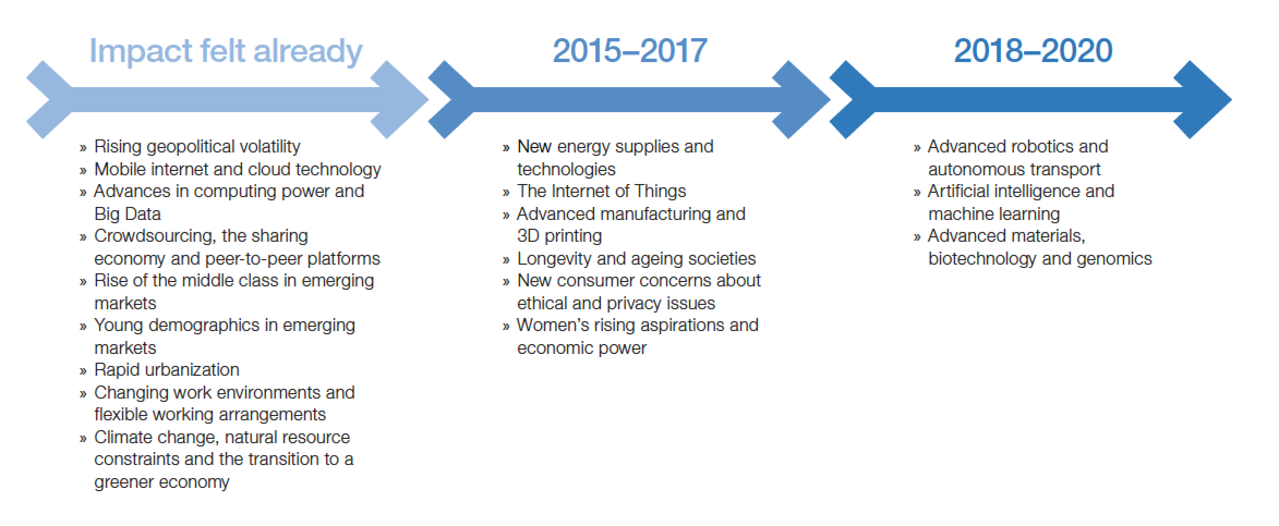

* **Evaluate emerging technologies**

Like many industries, technology has changed the landscape of personnel selection. How candidates apply and complete phases of the hiring process is dramatically different today than a decade ago. The future will be no different; technology advances will continue to impact every phase of the talent cycle, including how we select people to join our organizations. While innovative technologies often offer new ways of presenting and collecting information from candidates, not every emerging technology trend improves our selection processes.As advances are applied to our talent programs, it is critical to view these enhancements through the scientific lens that has been so useful in the last 50 years in helping organizations differentiate best practices from snake oil. While many new technological improvements create efficiencies and effectiveness, others may come at costs too great to bear. In order to evaluate these emerging discoveries, it’s important to understand the basic principles of hiring and ensure that the application of technology enhances our ability to make fair, predictive, efficient, and compliant decisions about organizational membership. In this article, we will explore some of the most recent trends in our field and consider how they stack up to the basic considerations that underscore effective personnel selection.

The challenges of ICT evaluation are not entirely new. For many years, since the first deployment of computers in business, researchers and practitioners have also grappled with evaluation of its impact. Just as we currently recognize the intrinsic connection between ICT and development, in the broad business sector there has long been the idea that the implementation of ICT is indispensable to the provision of effective organizational services.As a result, the implementation and management of ICT has presented both major opportunities and challenges to businesses. Amongst these challenges, the increased complexity of ICTs combined with the uncertainty and unpredictability associated with its benefits and costs, pointed researchers to the development of sound evaluation methods that offer companies a deeper insight into the impact of their ICT investment (Irani, Love & Zairi, 2000).

The business benefits of ICT gained much attention about twenty years ago, when economist and Nobel Laureate Robert Solow characterized the computer age by saying that “we see computers everywhere except in the productivity statistics” (Solow, 1987). This anomaly became known as the productivity paradox of information technology, and there were various reasons offered to explain this paradox, such as “deficiencies in [the] measurement and methodological toolkit” and the “mismeasurement of outputs and inputs” (Brynjolfsson, 1993:66). Other researchers before Solow had explored the potential business benefits of ICT as early as forty years ago (e.g., Boyd & Carson, 1963; Gallagher, 1974; Lucas, 1973). These early studies were concerned with whether technology was being effectively used, and explained this effectiveness in a variety of ways ranging from relatively simple accounting measures to complex multi-dimensional balanced score-card type metrics (Bannister, Berghout, Griffiths & Remenyi, 2006); they also explored the use of surrogate measures such as user satisfaction, service quality, individual, and organizational impact (DeLone & McLean, 1992; Lomerson & Tuten, 2005; Seddon, Staples, Patnayakuni & Bowtell,1999; Whyte, Bytheway, & Edwards, 1997).

There are three phases that describe how business interest in ICT evaluation has evolved over the years. These can be mapped against three distinct eras of ICT deployment in business. Laudon and Laudon (2000:15-16) describe the evolution of these eras: “In the 1950s the effects of IS [Information Systems, or Information Technology] on organisations brought about merely technical changes, only serving to automate clerical procedures. During the 1960s and 1970s IT had an impact on managerial control, and from the 1980s onwards IS impacted upon core institutional activities such as products, markets, suppliers and customers”.

# Chapter 1: Identify emerging technologies and practices in IT

**This chapter will help you learn about the following:**

* Access sources of information on emerging technologies and practices in the IT industry
* Identify and document emerging technologies and practices relevant to organisational context

## 

# 1.1 Access sources of information on emerging technologies and practices in the IT industry

# 1.2 Identify and document emerging technologies and practices relevant to organisational context

**Difference sources of information to identify emerging technologies**

As an IT specialist, you need to be aware that what new technologies and practices are emerging that will make your organisation life easy. Either it helps to reduce the cost or improve the efficiency of the organisation.

You may need to follow different sources including:

* Follow the newsletter of Australian computer society and other relevant IT professional bodies
* Visit IT specific events to meet other IT people
* Go to the IT trade show
* Research on internet
* Follow major ICT companies movements

**Information on few emerging technologies in IT industry**

Emerging technologies include a variety of technologies such as educational technology, information technology, nanotechnology, biotechnology, cognitive science, psychotechnology, robotics, and artificial intelligence.



Here's a look at few trending technologies that IT professionals should be studying right now. Where these technologies lead us, IT jobs are certain to follow in order to help design, implement, and support each one.

Our goal for this list was to identify not only hardware and software technologies, but also ideologies and legislative movements that can dramatically influence how and when a particular technology will reach a critical mass in terms of impact on our lives. You'll find that our list contains not only technologies that are attempting to solve problems we see today, but also ways to move beyond what we have today and push us into uncharted territories.

As our technologies increase in complexity, it takes more and more time for technologists to start to comprehend new technologies, let alone learn how to implement and support them. So it's in our best interest to start our education as early as possible by first identifying the technology trends likely to shake up the IT landscape in the years ahead.

The proliferation of mobile computing around the world clearly indicates that a focus on future wireless technologies would make our list. The same goes for IT's hottest topic of the past few years -- IT security. Other technologies, such as three-dimensional imagery and robotics, will advance many areas of our lives that have remained stagnant for years.

**Few Trending Emerging technologies**

The following few emerging technologies in current IT sector are:

**1. Internet of Things (IOT)**

The network of physical devices, vehicles, home appliances and other items embedded with electronics, software, sensors, actuators, and connectivity which enables these objects to connect and exchange data."

One of the biggest tech trends to emerge in recent years is the Internet of Things. Simply put, the Internet of Things (abbreviated IOT) is the idea that all technological devices can be connected to the internet and to each other in an attempt to create the perfect marriage between the physical and digital worlds. How will this impact you? It depends on your industry. For example, for those who work in marketing, advertising, media or business management, IOT could provide a wealth of information on how consumers engage with products by tracking their interactions with digital devices. In turn, this data could be used to optimize marketing campaigns and user experiences.

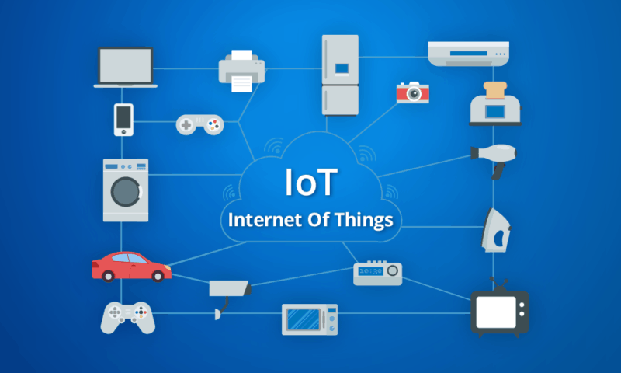

How it’s affecting industries: The really cool thing about IOT is that it’s not only changing the way we do business but also the business models we use to do it. For example, according to Deloitte, flexible consumption models (also known as pay-per-use models) are going become increasingly more popular across all industries as new customer data becomes available.

**Pros of Internet-of-Things:**

Internet of things has revolutionized Here are some advantages of IoT:

**1. Cost Savings**

It makes the electronic appliances communicate with each other in an effective manner thereby conserving and saving cost and energy; hence, it’s helpful to people in their daily routines. By allowing the data to be shared and communicated between electronic devices and then translating it into our required way, IoT is making our systems efficient.

**2. Information**

It is true that with more information, you can make better decisions. Whether it is general decisions as needing to know what to buy at a grocery store or if your company has enough supplies and widgets, knowledge is a great power and more knowledge is always good.

**3. Communication**

IoT encourages Machine-to-Machine (M2M) communication (communication between devices). Owing to this, the physical devices are capable to stay connected; hence, total transparency is available with greater quality and lesser inefficiencies.

**4. Automation and Control**

Owing to physical objects getting controlled and connected digitally with wireless infrastructure, there is a big amount of automation and control in the workings. All the machines are capable to communicate with each other without human intervention which leads to prompt output.

**Cons of the Internet of Things:**

Here are some cons of the Internet of Things:

**1. Over Dependency on Technology**

At present, it is observed that the younger generation is a technology freak and they depend upon technology and its devices for every little thing. With the help of IoT, this dependency will become even more in daily routines. No application is free from fault and there are some hitches in each technical application. Totally relying on IoT devices may create trouble in case of non-working or crash of an IoT infrastructure.

**2. Losing Security on Privacy**

As there is the involvement of different technologies and devices, there is monitoring by more than one companies, which directly questions the security and privacy issues. Data retrieval and storage also becomes a major concern for the companies because all of them are involved at the same time. In case of keeping only one company, it may lead to the question of domination.

**3. Lesser Employment Prospects**

With IoT, daily activities getting automated and naturally there will be fewer requirements of human resources and less educated staff, which may create employment issue in the society.

**4. Complexity**

With all complex systems, there is the possibility of failure. Failures could be a skyrocket in case of the Internet of Things.

**2, Artificial intelligence (AI)**

Artificial Intelligence (AI) is a science and a set of computational technologies that are inspired by—but typically operate quite differently from—the ways people use their nervous systems and bodies to sense, learn, reason, and take action. While the rate of progress in AI has been patchy and unpredictable, there have been significant advances since the field’s inception sixty years ago. Once a mostly academic area of study, twenty-first century AI enables a constellation of mainstream technologies that are having a substantial impact on everyday lives. Computer vision and AI planning, for example, drive the video games that are now a bigger entertainment industry than Hollywood. Deep learning, a form of machine learning based on layered representations of variables referred to as neural networks, has made speech-understanding practical on our phones and in our kitchens, and its algorithms can be applied widely to an array of applications that rely on pattern recognition. Natural Language Processing (NLP) and knowledge representation and reasoning have enabled a machine to beat the Jeopardy champion and are bringing new power to Web searches.

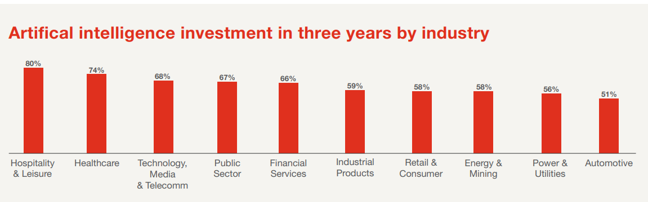

While impressive, these technologies are highly tailored to particular tasks. Each application typically requires years of specialized research and careful, unique construction. In similarly targeted applications, substantial increases in the future uses of AI technologies, including more self-driving cars, healthcare diagnostics and targeted treatments, and physical assistance for elder care can be expected. AI and robotics will also be applied across the globe in industries struggling to attract younger workers, such as agriculture, food processing, fulfillment centers, and factories. They will facilitate delivery of online purchases through flying drones, self-driving trucks, or robots that can get up the stairs to the front door.



**Pros**

AI is set to dominate the business, consumer and public sector landscape over the next few years with technologists predicting that soon we will be surrounded by IoT devices capable of performing mundane tasks and speeding up complex ones. Indeed, many of the benefits AI offer will centre around the workplace.

**Improve efficiency**

The value of data is now as important to business as oil once was and there is a need to process this data quickly and accurately for real time results. A good example of this type of AI is being used by DeepMind to diagnose sight-threatening eye conditions as accurately as the world's best clinicians.

Working with London-based Moorfields Eye Hospital and UCL's Institute of Ophthalmology, the results of their research could pave the way for the rollout of AI systems in hospitals across the country. The AI system reduces the time doctors spend studying thousands of eye scans and can diagnose patients within seconds.

**Eradicate human error**

From lapses in concentration to simple mistakes, even the best of us are prone to errors. But an artificially intelligent machine built to perform a specific task has no such idiosyncrasies.

Online grocer Ocado uses automated machines in its warehouse, controlling thousands of robots, communicating with them 10 times a second to coordinate the movement of hundreds of thousands of crates.

**Smart technology**

Much like Ocado, AI will be used to power much of our automated services in the future. From self-driving cars, that use AI to navigate roads and asses’ obstructions, to smart cities that are predicted to greatly improve our environments.

An AI machine's ability to process large data sets quickly and accurately will be vital for many smart technologies and environment to operate. An example of this is already in operation on many top range smartphones, where AI operates in the background constantly optimising its device.

**Cons**

As Spiderman's uncle Ben famously said, "with great power, comes great responsibility" and this is certainly true of AI.

In 2016, an industry-wide organisation including five Silicon Valley giants was formed, known as the Partnership on Artificial Intelligence to Benefit People and Society. This body works to promote the fair and ethical development of artificial intelligence technologies that have the potential to bring as much disruption as it will benefit.

**Job losses**

This is arguably the number one downside to AI consistently highlighted as a doom and gloom scenario were workers are laid off, unable to outperform machines.

Reports on this are conflicting. A recent study from PricewaterhouseCoopers (PwC) argued that AI will create just as many jobs as it culls. However, the report detailed that the new technologies will have an uneven effect on industries.

Where sectors like healthcare and education were predicted to benefit, laborious positions such as manufacturing and transportation operators were estimated to see the largest decreases in jobs. Former chess world champion Garry Kasparov has said these jobs losses were necessary to progress, arguing that it is outweighed by the societal good that AI can achieve.

**Robot bosses**

If you have an issue with your current human boss, be thankful that he isn't a cold, emotionless machine because AI is already being used to monitor work productivity.

In what seems like the scary nightmares of a dystopian future, IBM's Watson has been using AI and Watson Analytics to decide if employees are worthy of a pay rise, a bonus or a promotion by looking at the experience and past projects of employees to judge the qualities and skills that individuals might have to serve the company in the future.

**Man-made error**

Although AI can virtually remove human error from processes, it can still exist in the code, along with bias and prejudice. Being largely algorithm based, the technology can be coded to have a negative impact on certain demographics and discriminate against people.

Worryingly, if security is not 100%, hackers can take advantage of AI's thirst for knowledge. For example, Microsoft's ill-fated chatbot, Tay Tweets, had to be taken down after only 16 hours after it started to tweet racist and inflammatory content -- ideas it repeated from other Twitter users.

**3, Augmented Reality & Virtual Reality**

Augmented reality (AR) and virtual reality (VR) are becoming mainstream and have become a worthwhile topic in many industries. VR and AR development can be applied towards gaming, entertainment, marketing, education, fashion, art, and so much more. These are exciting new technologies that are being improved every day.

In 2014, there were less than one million VR users, but that number has incredibly grown to more than 150 million users this year. That number is expected to grow even higher over the coming years. According to a Zion Market Research report, the virtual reality market was valued at approximately $2 billion in 2016, and the market is expected to reach $26.8 billion by 2022. Software revenue from augmented and virtual reality has seen great success and will continue to see growth in the near future.

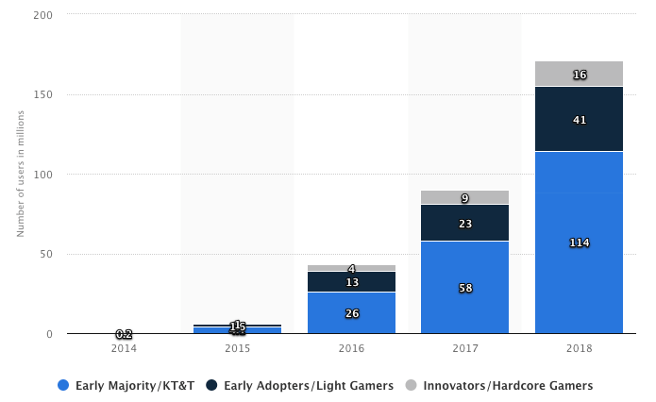

Difference between AR and VR

The terms "virtual reality" and "augmented reality" get thrown around a lot these days, thanks to the resurgence of VR headsets heralded by the Oculus Rift and the use of AR apps and games Go. They sound similar, and as the technologies develop, they bleed over into each other a bit. They're two very different concepts, though, with characteristics that readily distinguish them from one another.

Virtual Reality (VR)

VR headsets completely take over your vision to give you the impression that you're somewhere else. The HTC Vive, the Oculus Rift, and other headsets are completely opaque, blocking out your surroundings when you wear them. If you put them on when they're turned off, you might think you're blindfolded.

When the headsets turn on, however, the LCD or OLED panels inside are refracted by the lenses to completely fill your field of vision with whatever is being displayed. It can be a game, a 360-degree video, or just the virtual space of the platforms' interfaces. Visually, you're taken to wherever the headset wants you to go—the outside world is replaced with a virtual one.



Augmented Reality (AR)

Whereas virtual reality replaces your vision, augmented reality adds to it. AR devices like the Microsoft HoloLens and various enterprise-level "smart glasses" are transparent, letting you see everything in front of you as if you are wearing a weak pair of sunglasses. The technology is designed for completely free movement while projecting images over whatever you look at. The concept extends to smartphones with AR apps and games like Pokemon Go, which use your phone's camera to track your surroundings and overlay additional information on top of it, on the screen.



AR displays can offer something as simple as a data overlay that shows the time, to something as complicated as holograms floating in the middle of a room. Pokemon Go projects a Pokemon on your screen, on top of whatever the camera is looking at. The HoloLens and other smart glasses like the mysterious Magic Leap One, meanwhile, let you virtually place floating app windows and 3D decorations around you.

This technology has a distinct disadvantage compared with virtual reality: visual immersion. While VR completely covers and replaces your field of vision, AR apps only show up on your smartphone or tablet screen, and even the HoloLens can only project images in a limited area in front of your eyes. It isn't very immersive when a hologram disappears once it moves out of a rectangle in the middle of your vision, or when you need to stare at a small screen while pretending that the object on that screen is actually in front of you.

Basic AR that overlays simple information over what you're looking at can function perfectly fine with 3DOF. However, most AR applications require 6DOF in some form, tracking your physical position so the software can maintain consistent positions for the images it projects in 3D space. This is why the HoloLens uses a stereoscopic camera and advanced pattern recognition to determine where it is at all times, and why more advanced, AR-centric smartphones like the iPhone X use multiple rear-facing cameras to track depth.

**4, 3D Printing Technology**

3D printing is a fast-growing additive manufacturing technology, which uses powder materials such as metal or plastic to construct object based on the digital model file. 3D printing is an emerging high-end manufacturing technology, which is widely used in manufacturing and other fields. In the past years, this technology has changed the pattern of the manufacturing sector quietly.

Industrial CT system provides three-dimensional high-precision scanning of products, which result in high-precision three-dimensional computed tomography dataset with material and structure information of product. Industrial CT and 3D printing technology are two complementary technologies, has strong association with each other in industrial applications

Industrial CT and 3D printing technology

High-precision industrial CT and 3D printing technology is the world's most advanced three-dimensional scan and three-dimensional manufacturing technology. Presently, the digital model for 3D printing is mainly provided by optical scanning, which takes pictures from 360 ° angles around the scanning target by visible light. The 3D surface construction software calculates, modify, and create a digital 3D surface images of the object, and transmit data to the 3D printer. The 3D printer formed solids layer by layer.

By this method, only the outside structure data of the object can be obtained and constructed by 3D printing. For complex object, such as workpieces with an internal cavity structure, it is difficult to deal with. Industrial CT technology can achieve high-precision three-dimensional internal structure of complex structure objects without contact and damage object, can provide high-precision digital information required for 3D printing. In recent years, high-precision industrial CT and 3D printing are two rapid development technology in their respective service areas. In the industrial design and manufacturing fields, these two kinds of technology have not yet been combined use effectively.



The combination of both industrial CT and 3D printing in the field of design and manufacture, will complete such a process of "product - industrial CT scans – 3D digital model - 3D prints rapid prototyping". This process can integrate the advantages of both industrial CT and 3D printing, to achieve an efficient and convenient new design and manufacture mode and improve capabilities in the field of scientific research and manufacturing design.

The traditional way to handle the CT images in 3D printing consists of a series of process including binarize, edge detection, contour tracking and so on. Through these picturing processes, the CT images are transformed into STL or CLI files, which can be managed by slicing programs and finally be turned into machine-read scanning paths. The traditional process is shown as below figure

Such a method has great precision distortion, how to cut the intermediate links and improve the printing precision has been a main problem in the field of CT images and 3D printing.

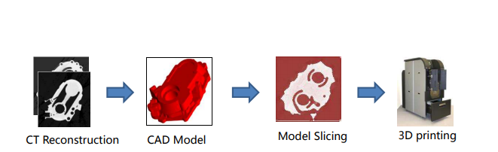

**5, Blockchain**

A blockchain is a write-only database dispersed over a network of interconnected computers that uses cryptography (the computerized encoding and decoding of information) to create a tamperproof public record of transactions. Blockchain technology is transparent, secure and decentralised, meaning no central actor can alter the public record. In addition, financial transactions carried out on blockchains are cheaper and faster than those performed by traditional financial institutions. These properties are at the heart of this technology’s rapid expansion.

This technology became widely known in 2009 with the launch of the Bitcoin network, the first of many modern cryptocurrencies. In Bitcoin, and similar systems, the transfer of digital information that represents electronic cash takes place in a distributed system. Bitcoin users can digitally sign and transfer their rights to that information to another user and the Bitcoin blockchain records this transfer publicly, allowing all participants of the network to independently verify the validity of the transactions. The Bitcoin blockchain is independently maintained and managed by a distributed group of participants. This, along with cryptographic mechanisms, makes the blockchain resilient to attempts to alter the ledger later (modifying blocks or forging transactions). Blockchain technology has enabled the development of many cryptocurrency systems such as Bitcoin and Ethereum1 . Because of this, blockchain technology is often viewed as bound to Bitcoin or possibly cryptocurrency solutions in general. However, the technology is available for a broader variety of applications and is being investigated for a variety of sectors.

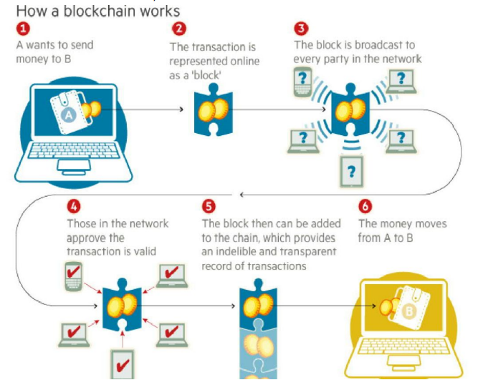

**Pros of Blockchain Technology**

**Transparency**

The decentralized nature of the blockchain is what makes them immune to take overs or corruption by centralized entities such as banks and governments. It goes further, while distributing this data across a wide network of unrelated computers and systems also means the blockchain’s ledger is available for anyone to access, verify & audit data and transactions.

**Accounting**

Blockchain allows you to record transactions that virtually eliminates human error and protects data from tampering. The data is verified every single time they are passed on from one blockchain node to the next.

**Supply Chain Management**

This revolutionary technology offers the benefit of trace ability and cost-effectiveness. Blockchain allows for the tracking of goods, their origin, quantity and more. This simplifies processes like ownership transfers, production process assurance and payments.

**Peer to peer global transactions**

Bitcoin which uses blockchain technology allows for fast, secure and cheap transfer of funds across the globes. While there’s already services like PayPal that processes international payments, they usually have specific limitations.

**Process Integrity**

Users can trust that transactions will execute exactly as the protocol commands and removes the need for a trusted third party.

**Lower Transaction Costs**

The elimination of exchanging assets through third party intermediaries allows blockchain to greatly reduced transaction fees.

**Cons of Blockchain Technology**

**Blockchain is Everlasting**

Every bitcoin network client stores the entire transaction history, it became as large as 100GB. The more transactions processed on the network, the faster he size grows. In addition to the data being stored, it needs to be downloaded as well.

**Miners Provide Network Security**

Since the blockchain has miners and giant mining farms built next to power stations, they burn lots of electricity. If only one-thousandth of the current number of miners existed and thus one thousandth of the electric power was consumed then bitcoin would still be as good as it is now. Miners also have the ability to produce 51% attacks which allows a miner with 51% of hash rate (mining power) to basically rewrite, write and remove blocks within the network.

**Indestructible**

Since blockchain is stored on each network node, then special services or authorities cannot shut down Bitcoin because it’s decentralized and has no centralized server.

**Performance**

When a transaction is being processed to does everything, a centralized database does but it has 3 more things that hinders its performance.

**Signature Verification**

All transactions made on the blockchain network needs to be signed using a public-private cryptography scheme called Elliptic Curve Digital Signature Algorithm (ECDSA) which in short offers digital signature generation using elliptic curves parameters. This is necessary because transactions propagate between nodes in a peer-to-peer fashion. The generation and verification of these signatures are computationally complex. In centralized databases, once there is a connection there is no need to individually verify every request that comes over it.

**Consensus mechanisms**

In a blockchain, effort must be expanded in ensuring that nodes in the network reach consensus. Depending upon the consensus mechanism used, this might involve significant back and forth communication and/or dealing with forks and their consequent rollbacks.

**Redundancy**

Since the blockchain has many nodes whereas centralized databases process transactions once or twice, the blockchain must process independently by every node in the network for the same end result.

Self-check assessment

Question 1: Briefly explain emerging technology in your own words.

______________________________________________________________________________________________________________________________________________________________________________________________________________________________________________________________________________________________________________________________________________________________________________________________________________________________________________________________________________________________________________________________________________________________________________________________________________________________________________________________________________________________________________________________________________________________________________________________________

Question 2: What is augmented reality?

________________________________________________________________________________________________________________________________________________________________________________________________________________________________________________________________________________________________________________________________________________________________________________________________________________________________________________________________________________________________________________________________________________________________________________________________________________________________________________________________________________________________________________________________________________________________________________________________________________________________________________________________________________________________________________________________________________________________________________________________________________________________________________________________________

# CHAPTER 2. Evaluate the impact of emerging technologies and practices

**This chapter helps to understand the following:**

* Evaluate features and functions of emerging technologies and practices to determine advantages and disadvantages relevant to organisational context
* Assess and document potential impacts of emerging technologies and practices on current organisational technologies and practices
* Seek and obtain feedback from organisational representative on assessment of impact of emerging technologies and practices and incorporate feedback into report

2.1 Evaluate features and functions of emerging technologies and practices to determine advantages and disadvantages relevant to organisational context

**Evaluation of Emerging technologies**

At several points in the phased evolution of the technology development and transfer process, it will be necessary to assess and evaluate potential identified technologies and a hypothetical development and transfer process. Therefore, it is necessary to have criteria for evaluating relative appropriateness of various technology development or transfer strategies in order to determine appropriately meritorious technologies and associated development and transfer strategies. There are many factors that need to be considered in doing this. Large-scale technology development consumes financial and other resources, often for a significant time period. It is invariably necessary to recognize that the benefits of developing one particular technology strategy alternative must be weighed against the costs of foregoing other opportunities.

There are a number of issues to be resolved through the evaluation efforts accomplished as part of the systems management of technology development and transfer. These include:

- determining an appropriate *specific* process to use for the identification and evaluation of potential technologies for development and/or transfer;  
- identifying the groups that should be involved in this identification and evaluation process;  
- identifying the criteria that will be used to determine length and type of support;  
- identification of appropriate criteria to determine transferability of the technology to full-scale operational deployment status or termination.

Each of these relates to the criteria that will actually be used for evaluating emerging technology development strategies. I have discussed many of these criteria in our efforts this far. Summary of many appropriate evaluation attributes:

(1) Technological merit

(a) Technological objectives and significance  
(b) Breadth of interest of strategy  
(c) Potential for new discoveries and understandings  
(d) Uniqueness of proposed development strategy

(2) Social benefits

(a) Contribution to improvement of the human condition  
(b) Contribution to national pride and prestige  
(c) Contribution to international understanding

(3) Programmatic (management) issues

(a) Feasibility and readiness for development   
(b) Technological logistics and infrastructure   
(c) Technological community commitment and readiness   
(d) Institutional infrastructure and implications  
(e) International involvement  
(f) Cost of the proposed strategy

**How to Evaluate Technology Solutions**

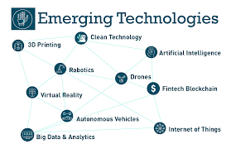

## As technology solutions become an operational necessity, these four steps can help you determine which programs and systems are right for your foodservice business.

## The restaurant industry has historically been a technology laggard, trailing others in employing technological business solutions. But in recent years, a significant increase in technology use is pushing more and more foodservice operators to become early adopters. Several factors are driving this, including:

* Generational evolution: new generations, who adopt technology more readily, are becoming owner/operators.
* Cost management: as operating costs increase, savvy operators are employing technology to offset them and remain profitable.
* Guest expectations: as younger age groups fill tables, they expect technology to be part of their dining experience.
* Employee needs: younger generations also are filling open positions and are looking to use technology to make their jobs easier and more efficient.

## Defining technology solutions

Any technology that helps with business execution and guest/client and employee interaction is a technology solution. They could include, but are not limited to:

When a technology evolution like this hits the market, some operators want to “catch up” and implement solutions right away. Instead, take the time to evaluate potential solutions and determine if the benefits warrant the investment.

**4 Steps to determine if technology is right for you**

Deciding whether to employ a technology solution should be based on how the solution will impact guests. Keep in mind every solution will affect the guest experience to some degree. The aim is to enhance the guest experience, as a great guest experience is a key differentiator in this competitive market.

To decide if a piece of technology is right for your operation, follow these four steps.

1. Define the business need and goal  
Write out a sentence or two on what the issue is and your goal, and how a new technology solution may help you achieve the goal.

Example: We want to capture all of our sales data and improve speed of service through a new POS system that allows us to take orders tableside.

2. Determine if the goal could be achieved without technology   
Posing such a simple challenge ensures an existing solution or adjustment to  practices couldn’t achieve the same goal, avoiding the additional cost and change management that comes with new technology.

Example: Could I simply update my system with correct pricing and PLUs or physically move the system to make it easier for my team to use?

3. Conduct a simple return on investment (ROI) analysis  
See how costs add up and what you’ll get for the money by looking at the benefits of making such an investment.

Cost

How much will the system cost?

What are the hard costs? (equipment, software, etc.)

What are the soft costs? (training, guest communication, internal change management, short-term executional changes, etc.)

What other aspects of your business will it impact and for how long?(Example: I think it will take 6 weeks to get a new reservation system up and running and my team and guests comfortable with using it. So I need to get that done no later than 11/15 to make holiday execution easier.)

Return

How much in incremental sales or profits do you need to cover the hard costs?

How long should it take to achieve those sales/profits?

How do you measure guest experience and what’s your benchmark for it?

What’s your goal for an improved guest experience? When do you hope to achieve that goal? (Note: you will need to use the same method of measurement to make sure your benchmark and progress are an apples-to-apples comparison.)

It’s imperative to weigh the cost vs. the ROI and define measurable goals before investing in any technology solution.

4. Compare at least three vendors  
These steps offer more of a scientific approach to evaluating technology solutions. But the reality is you will also get information (solicited or not) from vendors, friends, business associates and even articles. While all input is worth considering, validating what your analysis tells you vs. what you hear vs. what your business needs are can keep emotions and biases in check and allow the wisest decisions.

A comparative model will either validate your decision or expose the need to look at other technology solutions. Write down your minimum requirements (needs) and “nice to haves” (wants). Rank each vendor on each want and need using a score of 1-10 (10 being highly needed/wanted and 1 being a minor need/want) and compare scores. Your needs should rank highly with eligible vendors. Use wants as a tiebreaker, if necessary.

**Function and applications of emerging technology in a organisation**

Organisations are constantly trying to adapt, survive, perform and influence. However, they are not always successful. To better understand what they can or should change to improve their ability to perform, organisations can conduct organisational assessments. This diagnostic tool can help organisations obtain useful data on their performance, identify important factors that aid or impede their achievement of results, and situate themselves with respect to competitors. Interestingly, the demand for such evaluations is gaining ground. Donors are increasingly trying to deepen their understanding of the performance of organizations which they fund (e.g., government ministries, International Financial Institutions and other multilateral organizations, NGOs, as well as research institutions) not only to determine the contributions of these organizations to development results, but also to better grasp the capacities these organizations have in place to support the achievement of results.

**Advantages of Emerging Technology**

There are many advantages of emerging technologies:

1. It allows you to express your ideas so that others can learn from you (Blogs)

2. Technology connects you with people who are very far away (Skype)

3. Emerging Technology is able to allow you to receive information almost instantaneously (Twitter or Dropbox).

4. Technology allows you to learn in a more fun way, especially with games.

5. Emerging technology such as MOOCs can provide education for people who cannot afford it or for people who would like to learn more than school provides.

**Disadvantages of Emerging Technology**

Here are some of the disadvantages:

1. It is very difficult to remove anything from the internet completely; and thus, once an idea is online, it can usually be traced back to you.

2. Use of emerging technology can lead to identity theft if the user does not protect their virtual image.

3. It takes away the personal aspect of life especially if learning is done online.

4. It is difficult to use emerging technology to teach because students tend to surf the internet instead of paying attention.

## 

2.2 Assess and document potential impacts of emerging technologies and practices on current organisational technologies and practices

The growing impact of emerging technologies

Artificial intelligence, blockchain and virtual /augmented reality are helping organisations with their digital transformation strategies. The growing impact of emerging technologies image

Early adopters of blockchain are using it to confirm digital identities or maintain an audit trail for compliance.

Amid a wave of hype around emerging technologies three specific trends are showing the potential to help businesses transform the way they operate, according to a series of research briefs published by CompTIA, the technology industry association.

To varying degrees, artificial intelligence (AI), blockchain and virtual reality (VR)/augmented reality (AR) are staking out a more prominent role in the digital operations of organisations, the publications reveal.

“Though the majority of businesses are still on the sidelines, use cases for each of these solutions are beginning to emerge,” said Seth Robinson, senior director, technology analysis, CompTIA.

“When you consider that these are not standalone products that you plug in and play, but building blocks to automate, digitise or streamline operations, the impacts they are already having illustrate their potential.”

CompTIA surveyed some 700 business professionals at U.S. companies to gauge their awareness and usage of AI, blockchain and VR/AR.

VR has the greatest awareness among companies aware of the trend (74% of respondents), but blockchain is having the biggest impact today (43%).

Potential Impact of emerging technologies on current organisation

Popular media suggests that technological advancement will continue to have a dramatic effect on work, but it is difficult to distinguish between the hype surrounding this and the actual potential impacts.

This study examines what the evidence is in relation to the impact of emerging technologies on work and the role of the human resource (HR) function in helping employees and organisations to navigate these changes. Evidence suggests that the latest technologies, such as artificial intelligence and robotics, are being employed by organisations to automate simple and repetitive tasks as well as to make complex decisions quickly and more accurately via predictive algorithms. In addition, emerging technologies are increasingly being used to support the implementation of more flexible working practices such as virtual work and gig work.

However, this will present a number of challenges for HR professionals, who will need to help employees to update their skills to compete in the future world of work, and to find ways to address the possible negative effects of increased connectivity and precarious working arrangements on employee wellbeing.

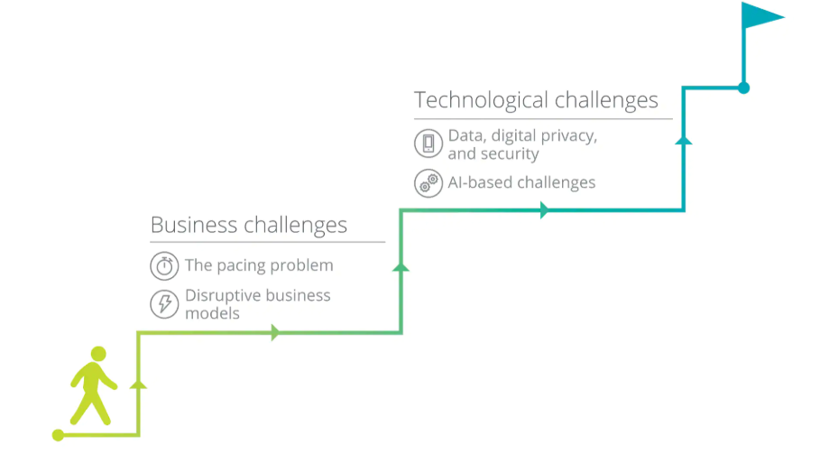

Over the last few years, we have seen a vast amount of attention paid to the impact of technological development on work, sometimes referred to as the changing world of work, particularly by popular media and consultants. Newspaper headlines such as “Robots will take our jobs. We’d better plan now before it’s too late” (Elliott, 2018) have become commonplace.

Some commentators also suggest that advances in technology will lead to changes in the workplace as dramatic as the collapse of the traditional employment relationship, the widespread use of artificial reality instead of travel and the replacement of humans with artificial intelligence (AI) and robotics. It is true to say that the most recent advancements in technology, such as AI, are having a dramatic effect on the workplace. Indeed, we are seeing rapid growth in the use of AI and robotics to automate simple and repetitive tasks such as factory work and many back-office duties; and to make complex decisions, such as medical diagnostics, quickly and more accurately via predictive algorithms.

A recent study from Frey & Osborne (2017) found that around 47% of total employment is in the high-risk category – i.e., jobs expected to be automated over the next decade or two. Technological advancement is often associated with other changes within the world of work that might be facilitated by the technology itself, like for example, the disintegration of the traditional employment relationship to be replaced by gig economy work; an increased emphasis on flexibility and agility at work; and a new generation of employees with vastly different attitudes to the previous workforce. Amongst all of the propaganda surrounding the impact of technological advancement on the future of work, however, it remains unclear what the actual evidence base is in relation to this and what the role of the human resource (HR) function will be in supporting the organisation and its employees in navigating these changes.

**Methods and Evidence**

An analysis of published evidence relating to the impact of technology on work and people management was undertaken. Evidence reviews typically focus on peer-reviewed, academic papers. However, due to the time it takes to research and publish such outputs, and the speed of change in relation to technology, published information on technological advancement and its impact on work and people management tends to be slightly out of date. In order to address this limitation, we broadened our review to include the grey literature, and research undertaken by consultancies and similar bodies.

A comprehensive review of the existing evidence in relation to how technological advancement has/is changing the world of work; what technological trends are likely to directly affect work, the workplace or the workforce; and the role of HR in relation to these changes was therefore undertaken. To identify published evidence related to the above areas, a list of appropriate keywords and search strings was identified. These were grouped into the following six thematic areas: technology, work, future, HRM, working practices, and other trends see following Table.

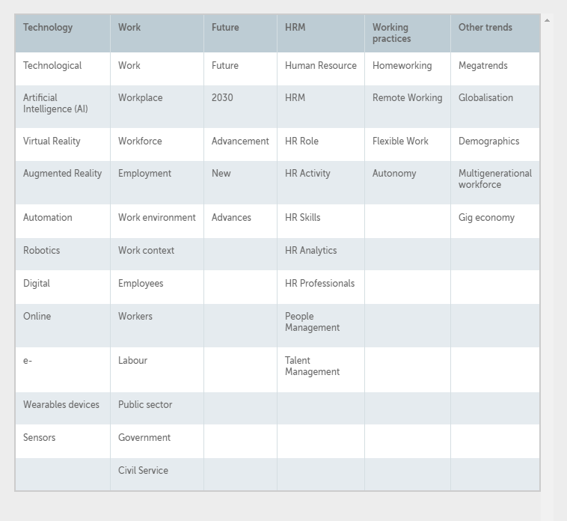

These were identified via searches on online databases and the Internet (via ABI/INFORM Complete, ScienceDirect, Scopus, Web of Science, and Google) as well as via recommendations from experts in this field. Relying on both academic and non-academic databases is important given the nature of the subject matter, which is fed by various disciplines, including Psychology, Sociology, HRM, Organisational Behaviour, Information Systems, Computer Science, Innovation and Organisation Studies. Given the high speed of changes in technological advancement, we focused most of our attention on publications between 2010 and 2018 in order to gain the most up to date scenarios for the future of work.

Evidence suggests that there are enormous financial incentives for employers to increasingly automate their (currently human) processes (Markoff, 2011) and that advances in automation could dramatically change the nature of jobs available (PWC, 2017). Realistically, whether a task can be automated depends on the ability of coders to write a set of procedures that will improve the problem specification and account for every possible contingency (Frey & Osborne (2017)). Despite this limitation, automation is increasingly being used in areas that require the storing or access of information (Frey & Osborne (2017)), such as in fraud detection, medical diagnosis (Cohn, 2013; Wolcott, 2018) and law (Markoff, 2011). In addition, the automation of manual tasks is increasingly widespread, including tasks such as driving (Autor et al., 2003; Veres et al., 2011), cargo handling (Bloss, 2011) and mining (Frey & Osborne (2017)).

The role of HR practitioners in the process of automation is not clear from the evidence, but it would seem that they could play a key role in identifying tasks (and thus eventually roles) that could be automated. Perhaps more important however, is the HR function’s role addressing the impact of job losses as a result of automation (Frey & Osborne (2017); PWC, 2017). Not only should HR practitioners be central to supporting employees through a period of uncertainty while such decisions are made, they should also be responsible for considering how employees can be re-skilled or up-skilled in order to replace obsolete skills so that they can be retained in the workforce.

The evidence suggests that the type of knowledge, skills, and abilities required by organisations will change. For example, the need for routine cognitive and manual skills is decreasing, while the need for non-routine cognitive and manual skills has increased (Autor et al., 2003). Research suggests that organisations will need a workforce with increased skill variety, autonomy, and interdependence, as well as increased cognitive, creative, technical and social skills, (Liu & Grusky, 2013; Wegman et al., 2018), to complement machines (MacCrory et al., 2014) and to perform the remaining tasks that are not automated (Makridakis, 2017). The HR function has a key role in ensuring the recruitment and development of these competencies as well as in designing leader development programmes that consider the new challenges related to managing employees in a modern work context and in coordinating humans and machines (Frey & Osborne (2017)).

**Implications of emerging technology on current organisation**

The findings of the evidence review and above discussion suggest that emerging technologies such as AI, robotics, VR and AR, digital technologies, wearables and blockchain have the potential to affect work and employees significantly. The degree and speed of this impact depends to a large extent on developments in the technologies themselves and the willingness of organisations to adopt them. This review also indicates that the HR function has a key role to play in helping employees to navigate the changes to the world of work particularly in relation to skills development, work organisation and mental health. While the key activities involved in HRM – to support managers in employees in going about their daily work (CEB, 2018) – are unlikely to change, the role of the HR function may become even more important as both the potential benefits and risks of emerging technologies for employees develop. Whether the HR function can successfully undertake this role depends upon their own skills development and their own understanding of technologies and their implications. Jesuthasan (2017) suggests that sustaining digital engagement in the future workplace will become a key part of the HR role. We would go beyond that statement and propose that actually the role of the HR function is also to develop and support employees in order to ensure their growth and wellbeing, as well as the sustainability of the organisation, against the backdrop of this technological advancement.

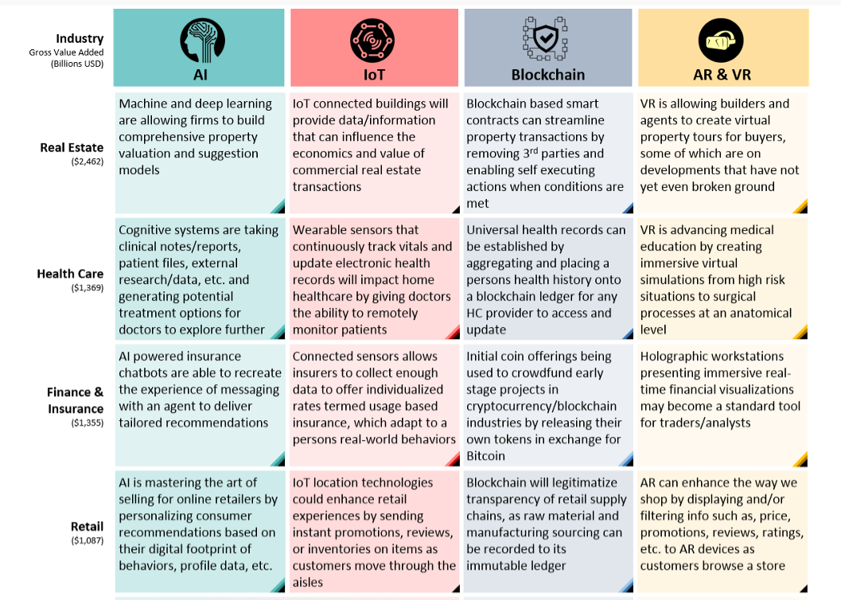

**Potential impacts of emerging technologies**

Every organisation is different so there will different impacts to the different technology and organisation. We have list some of the common potential impacts of the emerging technologies.

* Driverless cars
  + A lot of people will be jobless
  + Media issues
  + Robot testing
  + Car crash reduce
* Virtual reality
  + Less travel time
  + Save time
  + Cost effective
  + People may not be able to connect as before
* Cloud computing system in the organisation
  + All the staff can access the data from anywhere in the world
  + Save hardware and cost
  + Security can be an issue
  + Save IT cost
  + Some IT people may lose job
* 5G internet
  + Update hardware and software devices
  + Update the old cabling if any
  + Improve the speed and performance

2.3 Seek and obtain feedback from organisational representative on assessment of impact of emerging technologies and practices and incorporate feedback into report

**Obtain feedback**

You need feedback to learn and grow. Receiving feedback can be “a stressful experience,” says Ed Batista, an executive coach and an instructor at the Stanford Graduate School of Busines. That’s why many people hesitate to ask for it. But the more often you do, [the less stressful it becomes](https://hbr.org/2014/08/make-getting-feedback-less-stressful/) to initiate the conversation and to hear the comments.

“If you’re having a feedback conversation every week, there’s less to be surprised by and more opportunity to modify your behaviour,” Batista explains. The process will also make you happier and more productive at work, adds Sheila Heen, author of [Thanks for the Feedback: The Science and Art of Receiving Feedback Well](http://www.amazon.com/Thanks-Feedback-Science-Receiving-Well/dp/0670014664). “People who go out and solicit negative feedback meaning they aren’t just fishing for compliments report higher satisfaction,” she says. “They adapt more quickly to new roles, get higher performance reviews, and show others they are committed to doing their jobs.” Here’s how to ask for feedback that helps you get ahead.

**Understand what you’re looking for**

Think about the kind of feedback you crave. Do you want more appreciation or acknowledgment? Evaluation of your performance on a particular project or task? Or [general coaching](https://hbr.org/2014/01/find-the-coaching-in-criticism) about how you can improve and learn? Knowing this will help you craft your approach, says Heen. “You can go to your boss and say, I feel like I get a ton of appreciation around here. I know I’m valued. What I don’t have a sense of is what I need to work on.” And while advice on areas in which you can develop is often the most useful, “there is value in asking for positive feedback as well,” says Batista. Don’t hesitate to ask your boss to review your performance on an obviously successful project. “It’s can be an opportunity to build a stronger relationship,” he says.

**Ask for feedback in real time**

If you want some insight into how you did on a particular task or how you might improve on the next project, don’t dawdle. It’s best to ask sooner rather than later. Batista advises that you not try to do it all in one conversation. “Chop it up into manageable chunks and space out the interactions,” he says. You also don’t have to schedule time in advance or make a formal approach. “Don’t think of it as sitting down to have an official conversation,” says Heen. “Just reach out to your boss, colleagues, or clients and have a very quick and informal coaching exchange.” You might pull your boss aside after a meeting or close a conversation with a client with a parting request for her reaction to your role on a recent project.

**Pose specific questions**

Whatever you do, don’t start off by asking, Do you have any feedback for me? “That’s a terrible question,” says Heen. “The answer is almost always no and you learn nothing.” She recommends instead asking, What’s one thing I could improve? so it’s clear that you’re asking for coaching and it’s clear that you assume there’s at least one thing you can work on. You can also tailor the question to the specific situation: What’s one thing I could have done better in that meeting or presentation? You should also avoid asking questions that are likely to result in yes or no answers. “Asking questions that begin with ‘how’ or ‘what’ will elicit fuller responses,” Batista says. He suggests questions like, how did that go from your perspective? or What do you think I might have done differently?

**Press for examples**

To get the most out the feedback once you’ve asked, you may have to probe for specifics. “Sometimes, the person will say ‘I just think you need to be more assertive or more proactive or more of a team player,’” says Heen. “That’s vague and what we call a label. It’s not very helpful. You have to unpack the label.” To do that, ask probing questions like, Can you explain what you mean? How could I have been more assertive just now? and What kinds of things should I do to be more assertive going forward?

**Turn to colleagues**

Your boss certainly isn’t the only one qualified to give you feedback. “The people in the meeting with you or reading your spreadsheets are the ones who actually have the information to help you improve,” she says. So when looking for input, don’t just look up the organizational chart, but also left, right, and occasionally down. To kickstart a regular feedback loop with colleagues, offer input on, observations about, and praise for their work as well. “You’ll get more feedback when you’re giving some,” says Batista.

**On virtual teams, ask more frequently**

It can be particularly hard for [virtual team members](https://hbr.org/2014/12/getting-virtual-teams-right) to get regular feedback since physical distance often prevents informal exchanges. So “the onus is on you” to ask for more input, says Batista. Heen’s advice is to “pick up the phone.” Don’t rely on email because nuances tend to get lost.

**Principles to Remember:**

**Do:**

Understand the kind of feedback you want, whether it’s coaching, praise, or an evaluation of recent work.

Ask in real time. This will create a more organic feedback loop going forward.

Pose specific questions designed to elicit helpful information and examples.

**Don’t**

Just ask your boss for feedback. Ask colleagues, junior staff, and clients as well.

Think you have to schedule a formal meeting. You can have brief, informal coaching moments after meetings, in the elevator, and over coffee.

Rely on email when you are on a virtual team. Pick up the phone.

**Case study #1: Get the right feedback to grow**

Michelle Morgan, who works in online marketing in Missouri, couldn’t complain about the amount of feedback she was getting from her boss; he piled on the praise about her performance regularly. But she explains: “I wasn’t hearing anything that would help me grow. I very much wanted to become a bigger piece of what was going on and have more impact.”

She thought long and hard about the different kind of feedback she needed and decided to approach her boss. She sat down with him and asked how she could exceed his expectations. “I told him I wanted to be taking steps up the ladder rather than remaining stagnant where I was.” She also pressed him to create a specific set of goals for her: “If I were to wow you with my performance, what would that look like numerically?”

Her boss was impressed with her initiative, and began giving her more constructive feedback, detailing how she could expand her duties and stretch her skills. “If opportunities for growth came up, my boss would let me know in real time what step I could take,” she says. “The benefits of the feedback ended up far outweighing the initial awkwardness of asking for it in the first place.”

**Case study #2: Keep your questions narrow**

Chelsey*, a network engineer at a telecom company in Dallas, wasn’t getting much feedback from her superiors, and when she did, it was usually generic and vague. “I would seek feedback on my soft skills,” she says, “and they’d say ‘you’re very personable.’ That feels good, but I can’t exactly use it to improve myself.” So she decided to look elsewhere.

After her first turn leading a project, she approached the client for feedback, asking specific questions about what he thought went well and what could have been improved. After receiving positive reactions, she then went to her boss, kicking off the conversation by sharing the encouraging feedback she’d received from the client. And since she specifically wanted to hear constructive criticism of her leadership on the project, she focused her questions on that topic. “I said, ‘I would like to get your perspective and hear what I can do better next time.’”

Chelsey said this initial interaction helped create a “virtuous cycle” of future feedback. “Once someone knows that you like to receive feedback, it gets easier,” she says. She also makes it a practice to ask specific questions like: “How effective would you rate my leadership style?” or “How do you think I could have handled situation X better?” she says. “It usually results in more constructive feedback.”

**Incorporate feedback into report**

**Once you receive a feedback from your colleagues and other peers regarding emerging technology. You need to make sure that you define given feedback in a formal report. Your report may include:**

* Background of emerging technology
* Different emerging technology that you will use
* Impact of the emerging technology
* Feedback from colleagues and peers
* Conclusion

Self-check assessment

Question 1: what are the potential impacts on emerging technology?

________________________________________________________________________________________________________________________________________________________________________________________________________________________________________________________________________________________________________________________________________________________________________________________________________________________________________________________________________________________________________________________________________________________________________________________________________________________________________________________________________________________________________________________________________________________________________________________________________________________________________________________________________________________________________________________________________________________________________________________________________________________________________________________________________

Question 2: explain few points about the implications of emerging technology?

__________________________________________________________________________________________________________________________________________________________________________________________________________________________________________________________________________________________________________________________________________________________________________________________________________________________________________________________________________________________________________________________________________________________________________________________________________________________________________________________________________________________________________________________________________________________________________________________________________________________________________________________________________________________________________________________________________________________________________________

# Chapter 3. Develop strategies to prepare for emerging technologies and practices

**This chapter helps to understand the following:**

* Develop and document strategies to prepare organisation for impacts of emerging technology and practices
* Identify and document changes to organisational technologies and practices required based on strategies to determine organisational response
* Seek and obtain feedback from organisational representative on strategy and organisational response from organisation and incorporate feedback into strategy and organisational response

3.1 Develop and document strategies to prepare organisation for impacts of emerging technology and practices

**How to create an IT strategy**



The accountability and strength of your IT strategy can have an incredible impact on your organisation. Naturally, the effectiveness of this strategy will directly correlate with the level of success you enjoy during your tenure.

Here are 7 steps for creating a technology strategy that will work.

**Step 1: Build a team**

You must lead and drive the whole strategy from start to finish. This doesn’t mean that you do all the work. Put together a team of people who have a sense of ownership. You want absolutely everyone to buy into your strategy.

Look for direct reports that have a passion for this topic and engage them. Also consider leaders who actually need to develop a stronger strategic focus people who get along with and respect others and want to be challenged.

In the past, I have used an ‘Office of the CIO’ construct as a way to ensure people work closely with me and help build the strategy. This improves engagement and helps to develop the skills of staff members on the team. In a previous role, I discovered that some of skip level managers knew more about IT strategy than some of my direct leaders.

**Step 2: Align with the business’ objectives**

The classic approach is to be aligned with the business strategy. As a CIO, you are both part of the business and represent IT, so by definition, this process of alignment requires you to educate others and yourself to deep dive into the business.

This engagement and feedback process is critical to attain the magic moment of alignment. It is true to say that alignment is not a ‘natural’ state and requires you to be open to input and to take a real stance on what matters.

**Step 3: Draw up a proper plan**

Create a plan that establishes the correct parameters and illustrates exactly what needs to happen during at least two, and ideally three years. Unfortunately, many enterprises create plans with a myopic one-year view.

It’s right to assume that team members will become somewhat less confident about certain details and hitting some goals as time goes on but it is important to ensure you continue to be focused on long-term objectives. During the planning process, demand for people to complete certain tasks will often exceed supply, and your peers will have their own ‘pet’ projects.

Taking a medium to long-term view will allow a true transformation to be planned and executed. Such large-scale changes always take more time and effort than anticipated so make this clear to your team.

I once worked for an organisation that went five years without creating a tech strategy, there were many strategic projects all linked to business goals but no comprehensive plan or agenda. Yes, there were plans and successful projects but they all had a ‘one year’ view. Nobody planned beyond this and as a result, tactics overruled strategy.

**Step 4: Align the architecture roadmap with the strategy**

Having the IT strategy and architecture roadmap fully aligned is mandatory – it’s essential to have some clarity on the ‘wants, needs and givens.’ The architecture roadmap provides a ‘lens’ on these givens along with grounding on the current and future state.

Your architecture roadmap needs to provide a technical view of the maturity of the current applications and hardware infrastructure. It must highlight when this equipment reaches end-of-life – this is often the ‘forgotten cousin’ that nobody wants to discuss. Linking new business initiatives with the remediation of legacy apps and systems will provide the reality check you need to maintain the right balance for your IT strategy.

The best practice is to use an architecture roadmap as an ‘artifact’ to represent discussions between the IT group and the rest of the business.

There is a natural hesitation to share too much with business partners but in reality, not sharing is a mistake because your architecture and strategy team needs to be engaged with key stakeholders to build a common lexicon and understanding. This has to start by explaining how a detailed technical architecture supports planned changes across the business.

**Step 5: Make strategic choices**

There will never be sufficient funds and resources to meet every demand regardless of the size of your enterprise. This is always a hard pill for the business partners to swallow and there will be strong push to over commit. Your role is to be clear about these limitations.

I’m sure that are moments where the business has clear business strategies and priorities, but frankly this is not the rule. Even the best-planned enterprises will have ‘ad hoc’ regulatory or strategic projects that emerge out of the planning timeframe.

One key tip to identify planning assumptions and make it clear exactly what is included in the strategy. For example, staff utilisation might be 100 per cent at the start of the year but you need to allow for holidays, training or vacancies.

Another key thing to think about is what I call ‘discovery’ – there will always be strategic digital projects or similar that comes from the top and require investigation. There has to be a plan for this so a budget can be allocated.

**Step 6: Realise the ‘business of IT’**

Your IT strategy needs to provide a framework for how IT is to be managed. This is what I call the ‘business of IT’ and this framework includes ‘organisational architecture’ aspects such as structure, capability and competencies.

You are accountable for driving this agenda and ensuring that the enterprise understands how IT is improving.  The ‘business of IT’ will also address how IT will execute, incorporating engagement models with the business and more specifically, how DevOps or Agile methodologies will be taught to the team.

During this step, you are required to develop the target operating model and challenge the status quo.

**Step 7: Sign off**

You are near the end but it is not over yet. A symbolic process is the engagement and communications using broad and targeted messages. To this end a comprehensive plan of sharing with executive bosses, peers and within the IT function is needed.

This will require repetition and planning to ensure that the timing of these engagements all work with the overall timetable of the IT strategy. The very process of this engagement will mean that the actual sign off is already embedded and there’s nothing new that is revealed in the final read out.

Once the strategy is signed off and endorsed, it can then be shared more broadly across the enterprise. Having this level of endorsement from the CEO and c-suite is a critical step and will help you gain ground level support.

You’re now ready to start executing, good luck.

**Emerging technologies & industries strategy**

ICT will increase public sector productivity by enabling the delivery of world leading government services for Australian people, communities and businesses, supporting open engagement to better inform decisions, and improving the operations of government.

Today, the machinery of government depends on ICT. ICT will continue to transform government business and services to meet people’s expectations for better services, and to create a more open Government. Research points to the important role that ICT plays in driving productivity. ICT capital investment has contributed 17.5% of the total Australian productivity improvements since 1985 - it therefore warrants our close attention.

The Government’s use of ICT is largely agency focussed. The ICT Reform Program and coordinated ICT procurement arrangements have achieved greater integration, cooperation, and transparency. However, more visibility of the ICT design and investment intentions between government agencies is desirable. Decisions to acquire or upgrade ICT systems should consider the broader implications for government, people and business.

Rapid changes in the technology landscape continue, including the increasing use by business of technology developed for personal use, social media, mobile services, broadband and cloud computing. These changes can profoundly influence government and industry choices for ICT investment and how services can be delivered. The Government needs to balance the potential gains from innovation in ICT with the need to provide stable and reliable operations and services.

ICT Strategic Vision refocuses the Government’s ICT priority to improving productivity by delivering better services to people, communities, and business, engaging openly and improving government operations. The Vision is for streamlined interaction within government and between Government, people and business. This builds on and extends the gains made through the ICT Reform Program that focussed on the efficiency of ICT operations and building agency capability.

The Government will deliver the Vision and increase productivity through three strategic priorities – Deliver better services, Engage openly, and Improve government operations. Two strategic actions support the implementation of each strategic priority.

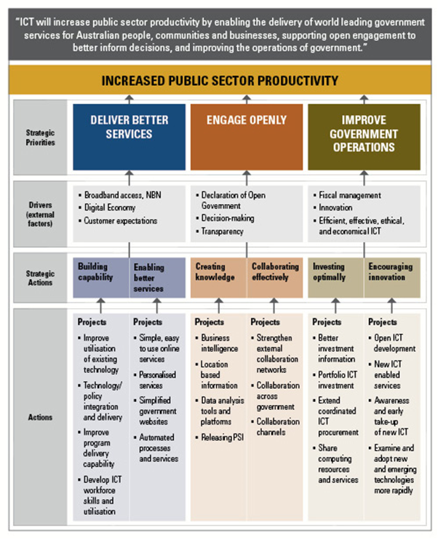

**ICT and Productivity**

Improvements in government operations and services have a significant effect on the productivity of the nation. The Government’s use of ICT provides an opportunity to improve our national productivity by making government more efficient and streamlining government processes and people’s interactions with government. Fewer and simpler interactions with government will allow people and businesses to increase their productivity, and as a consequence, that of the nation. This aligns with the efforts of Government to reduce “red tape” in order to streamline government and business operations and service delivery.

ICT is an important driver of productivity. The Productivity Commission has identified that investment in ICT capital results in improved labour productivity as well as directly enabling innovation. The OECD has found that ICT capital investment in Australia contributed to 17.5% of total Australian GDP growth between 1985 and 2006 , an annual average of 0.57%. This effect is supported by various reports and research, including:

• The 2009 Access Economics reports Revitalising Australia’s Productivity Growth and The economic benefits of intelligent technologies, which both identify improvements in productivity arising from the use of intelligent technologies in the electricity, irrigation, health, transport and broadband sectors;

• The Telstra Productivity Indicator Report , which provides evidence that ICT has improved productivity in the majority of the top 300 Australian companies; and

• The vast majority of witness statements and evidence provided to the Parliamentary Inquiry into raising the productivity growth rate in the Australian economy .

The Council of Australian Governments’ National Partnership Agreement identified 27 deregulation priorities to increase national productivity. This demonstrates COAG’s commitment to the reforms necessary to boost productivity and workforce participation, and improve delivery of services to the community. ICT is core to achieving these aims. The Standard Business Reporting program is an example of government helping business to reduce regulatory costs. It offers streamlined lodgement of reports and avoids the costs of duplicate reporting to improve the productivity of business and the broader economy.

**Strategic Actions**

The Vision has three strategic priorities and six strategic actions to support the primary objective of increased productivity. The graphic below shows how these elements align:

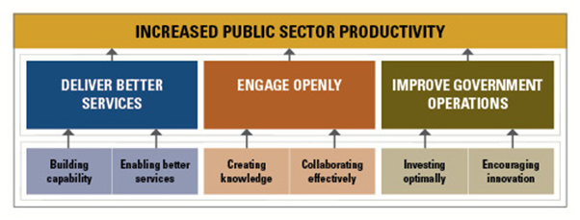

Government will deliver better services to support productivity growth through more effective use of the Government’s ICT capability. ICT will enable services that are streamlined and easy for people and business to use and will deliver greater productivity

Government will use Web 2.0 tools as part of its consultation processes to deliver better services by engaging more effectively with internal and external stakeholders, and making better use of the information arising from interactions.

Government will improve its operations by actively encouraging innovation and making better use of existing and new ICT capability investments. It will improve the way it identifies how to get the most value from its investments. This will include guiding and helping to shape policy choices to better use existing capabilities, speed delivery, avoid unnecessary duplication and complexity, and make best use of new and emerging technologies.

3.2 Identify and document changes to organisational technologies and practices required based on strategies to determine organisational response

Once, you define the strategies for the emerging technology. You need investigate the compatibility of the new technology with the existing technology including hardware, software, training need, cable, etc.

To investigate the compatibility, you need to conduct research on new technology and identify basic hardware and software requirements to use new system. Based on that information you can make judgement that what are the changes required in the current system.

For example: Your organisation wants to implement new 5G technology for the staff and the customer, so you need to investigate and identify the basic hardware and software requirements of 5G than compare the requirements with the current network to identify gap/s.

To update 5G, your organisation may need to upgrade the following:

* Cabling system from CAT 3,4 to CAT 6
* Upgrade the server or router to manage new requirements
* Upgrade old operating system from windows XP,2007 to Windows 10
* Download new software to manage 5G

3.3 Seek and obtain feedback from organisational representative on strategy and organisational response from organisation and incorporate feedback into strategy and organisational response

“Organizational strategy is a dynamic long-term plan that maps the route towards the realization of a company’s goals and vision.”

**Strategy is Dynamic**

Although your goals may remain the same, the strategy you adopt can change. Think of a game of chess. Your goal is to win. But to do so, you must adapt your strategy in the light of circumstances. If another player counters your opening gambit, there’s no point in continuing with the strategy, because it will fail.

What’s more, your vision can also change as time goes on. There’s nothing wrong with that, but it does mean that you need a new roadmap to success.

**Strategy is a Long-Term Plan**

How you define “long-term” is up to you. But the further ahead we look, the fuzzier things get. Most companies choose three to five-year strategic plans. This allows for greater certainty than, for example, a twenty-year plan.

But why not make the time frame even shorter than three years? The reality is that strategic planning takes a lot of time and effort. You’d probably have to start working on your next strategic plan at last six months to a year before you’ve completed all the actions you planned last time around. Without much in the way of results to progress from, shorter plans become meaningless.

**Strategy is a Road-Map**

Most strategic planning initiatives begin by asking the question: “Where are we now; and where do we want to be?” It covers everything from the identity of the company to its reason for existing. That’s why you will begin by formulating or revisiting your organization’s vision, mission, and values.

There are those who believe that “impressive sounding” vision, mission and values statements are the way to go. But if these statements are just there to impress your customers, they won’t benefit your business. Instead, your vision, mission, and values statements are there to define who your organization is, what it wants, and how it will achieve that. If your vision doesn’t inspire you and your staff – why work towards it? All members of the organization should be able to identify with the direction you are taking.

Once you have looked at the big picture of what you want to achieve, the next step is to look at the journey you will undertake. Just saying you want to achieve $1,000,000 in net profits, for example, won’t guarantee your success. What steps will your organization take towards that goal? Who will be responsible, and by when must they achieve results?

Returning to the roadmap analogy, what milestones will you need to reach as you progress with your journey towards a goal?

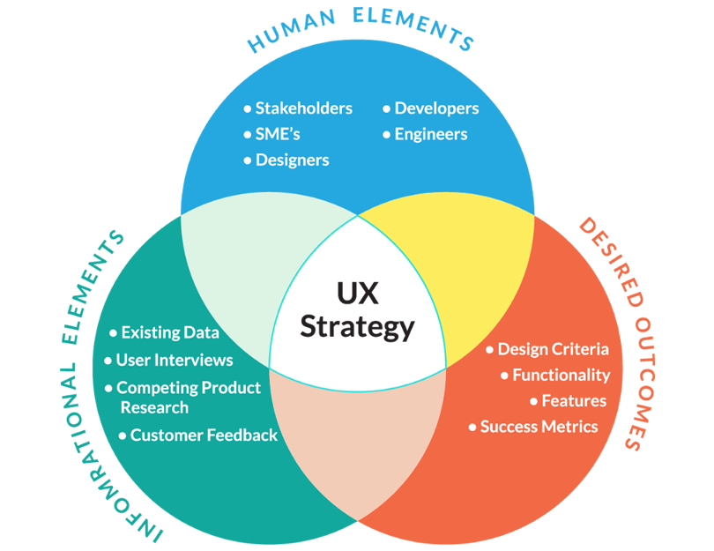

Organisational response from organisational technologies based on feedback and implementation of plan/strategy

No matter what size, companies are constantly looking to increase productivity, efficiency, and performance. Naturally, the implementation of new technology can accomplish that. However, while introducing new technologies is essential in running a successful company.

With careful preparation, strategic implementation, and honest evaluation, new technology can be seamlessly integrated and painlessly adopted by employees.

Here are a few tips for getting the most out of your next technology rollout:

**Work from the ground up** - when evaluating new technology, start from the most basic level. What's not working, what can be expected to change with newly implemented technology, and how its success will be measured. Then rank your priorities―functionality and cost are important, but don't undervalue user compatibility. Opt for systems that are accessible and intuitive to use.

**Offer productive support** - once you've chosen what technology you're going to integrate, make sure to have a complete support system for mitigating any difficulties in the transition. Consider a more modern approach to training. Move away from thick paper user manuals and opt for programs that have easily accessible digital help centers. Have everyone properly trained and comfortable with newly introduced technology before your launch date. If the intended audience feels intimidated when your launch comes around, or cannot access proper support when they need it, your entire implementation could fall apart.

**Avoid the impulse to rush** - it's important not to let the pressure and need to boost productivity allow you to handle implementation poorly. It may be tempting to introduce pilot programs as a means of cycling through technologies to find the right one, but taking commitment away from new technology integration can cause your entire process to fail. If you don't have a full program in place it will be difficult for employees to commit as well.

**Be transparent** - transparency can reduce friction that may potentially arise with the introduction of new technology. According to a survey conducted by the American Psychological Association, only fifty percent of employees believe that their employer is open and upfront with them. Employees who are kept in the loop and understand their role in the process will be more likely to help you achieve a seamless transition.

**Build value** - communicate openly with employees, speak to the organizational benefits of the new process, and explain what motivated the change. Address what could be at stake if the implementation fails, giving ownership to everyone collectively. Highlight the direct value of new technology for employees and trust them to become invested in its success. Value their opinions by taking the time to collect and address feedback.

**Maintain momentum** - the last thing that you want is for your new technology to come out of the gate strong, only to have things fall apart later on or to slip back into the status quo. To avoid this, put an individual or team in charge of the technology's success. Task them with not only overseeing the process from start to finish, but also monitoring ongoing usage after the implementation phase is over.

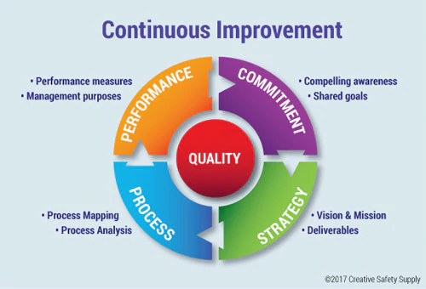

How to implement challenges required and its principles.

Organisations are confronted with many information management problems and issues. In many ways, the growth of electronic information (rather than paper) has only worsened these issues over the last decade or two.

Common information management problems include:

1. Large number of disparate information management systems.
2. Little integration or coordination between information systems.
3. Range of legacy systems requiring upgrading or replacement.
4. Direct competition between information management systems.
5. No clear strategic direction for the overall technology environment.
6. Limited and patchy adoption of existing information systems by staff.
7. Poor quality of information, including lack of consistency, duplication, and out-of-date information.
8. Little recognition and support of information management by senior management.
9. Limited resources for deploying, managing or improving information systems.
10. Lack of enterprise-wide definitions for information types and values (no corporate-wide taxonomy).
11. Large number of diverse business needs and issues to be addressed.
12. Lack of clarity around broader organisational strategies and directions.
13. Difficulties in changing working practices and processes of staff.
14. Internal politics impacting on the ability to coordinate activities enterprise-wide.

Ten key principles to ensure that information management activities are effective and successful:

1. Recognise (and manage) complexity
2. Focus on adoption
3. Deliver tangible & visible benefits
4. Prioritise according to business needs
5. Take a journey of a thousand steps
6. Provide strong leadership
7. Mitigate risks
8. Communicate extensively
9. Aim to deliver a seamless user experience
10. Choose the first project very carefully

Self-check assessment

Question 1: What steps are involved in strategic organisation implement?

______________________________________________________________________________________________________________________________________________________________________________________________________________________________________________________________________________________________________________________________________________________________________________________________________________________________________________________________________________________________________________________________________________________________________________________________________________________________________________________________________________________________________________________________________________________________________________________________________

Question 2: Explain the importance of collecting feedback from the organisation.

________________________________________________________________________________________________________________________________________________________________________________________________________________________________________________________________________________________________________________________________________________________________________________________________________________________________________________________________________________________________________________________________________________________________________________________________________________________________________________________________________________________________________________________________________________________________________________________________________________________________________________________________________________________________________________________________________________________________________________________________________________________________________________________________________

**BIBLIOGRAPGY:**

## https://study.com/academy/lesson/environmental-sustainability-definition-and-application.html

## https://www.gfs.com/en-us/ideas/how-evaluate-technology-solutions

## https://www.cio.com.au/article/632430/how-create-an-it-strategy/